View from the Trench

(Reprinted from The General, vol. 21, no. 5)
by Jon Mishcon
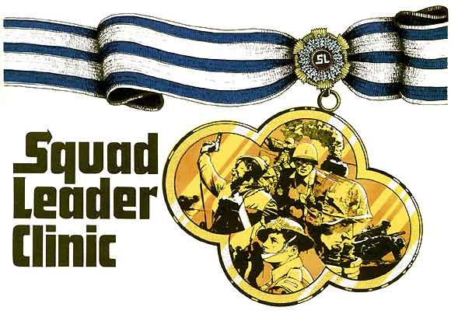
Now that you’ve heard a biased viewpoint on the impending release of ASL (namely, Don’s in this issue’s AH Philosohpy), here’s one that isn’t- Few people have played more SQUAD LEADER –in all forms– than on Mishcon, who has been activen in the ‘blind playtesting’ of the game system since its inception. And he’s proved, in these pages, to be a living “Gamer’s Guide” to the system. This is what he thinks.
Don has asked that I write down my feelings about ADVANCED SQUAL LEADER as “something of an outsider”. I say “something” because Joe Suchar and I have been involved with the ASL development pretty much since its first word was set to paper BUT (and this is a big “but”) we are not employees of The Avalon Hill Game Company. We’re gamers. Just that and only that. We read the rules, plunk down those pieces of cardboard, and roll the dice just like you do. The only reason we are on the playtest team is to give Don grief over scenarios and rules we won’t enjoy playing. I write this on the last day of January 1985 after having reviewed the latest –and hopefully last– complete rewrite. So allow me to anticipate your ASL questions:
Is it perfect? No, but it’s good.
After all these years, why isn’t it perfect? Every SL player has his own idea of perfection. Playability versus realism issues. "Little" ruels that reflect this or that nuance. The task of resolving the conflicting views of a bunch of strongminded playtesters would have given enven Job ulcers. One player's favovorite rule is another's curse. The present mix must be considered a reasonable compromise for players of all persuasions.
OK, let's have the bad news. First, it's a new game. Closely akin to SL, but NOT the same. All your old reflexes will need to be reviewed and reevaluated ;some of those old patterns will earn you a whole new crop of KIAs. Second, we feel take betweeen 10% and 50% longer to play (depending on the infantry/armor mix). Thirs, this version still has a greater “realism” flavor than playability. Maje no mistake, the playability has been increased (see below) but there is still a number of those “little rules” that seem to have impact only in a very special situations of course, you have to understand that we speak as very strong advocates of playability over realism.) Fourth, the scenarios are nothing to write home about: they seem designed to allow “introduction” to the system rather than demonstrate its strengths.
Strenghts? Sounds like I’m better off with GI? Listen, it’s loaded with strong features. A strong systems approach to rules have been made in ASL. Learn a concept and it aplies, with varying DRM, in all similar situations. This makes the game easier to learn an play. The rules make more sense. Most of the old funny rules that allowed “cute” tricks have been deleted. Mostly, I guess, it’s a distillation of the best of SL.
What is it like to play? Set-up has to be done for both players before game onset. No sniper or scout pieces (although searching and sniper fire are still present). Prep Fire is pretty close to that of GI with the notable exceptions that artillery fire isn’t called until the Fire Phase and that most weapons now have a rate of fire (roll less than or equal to that RoF and you get another shot; e.g., HMG-ROF 3). Movemeent is very close to the system of GI, but you’kkk have to spend one MF to start or stop an AFV. The biggest change is that ALL defensive fire is handled in one manner, very similar to the way you’ve always fired upon vehivles. A good compromise has been reached to prevent flooding an infantry position while still allowing you to “draw” fire. MGs still have lanes of fire but now they can, if you’re lucky, sweep back and forth. The Advancing Fire Phase is also integrated into movement with vehicles (only) allowed to move, stop, shoot, restart, and move again. The Rout Phase’s biggest changes are the “Low Crawl” (allowing a one-hex rout away in the open) and the prohibition of routing adjacent to enemy units. More huge changes to the Advanced Phase are evident. Close Combat now prevents the use of LMGs or leadership DRMs when the leader is alone in a hex, but each SMC always has a CC strength of one.
In short, there’s a lot less fooling around in the rules. Most importantly, the vast majority of the rules really will tend to benefit the player who thinks as did historical counterpart. (Sigh, and end to our torching most of the mapboard.) Otherwise, it is pretty close to GI.
But I like what I’m doing now. Why should I change? Most important is that Don has ruled THIS IS IT! Ther will be errata and updates, but in large part no further changes to the game system. That means that everybody can play all the scenarios. I plan to use “SQUAD LEADER Clinic” to release updates on old scenarios that will be balanced for ASL. The scenario production business will surely be getting busy again.

